# Name : Kumbhani Sanket Div : A

Roll_no : 3111 DCN[P]_Assignment-3

Program: 1

//Kumbhani Sanket - 3111 import java.io.*;

import java.net.*; import java.util.Scanner;

class server_checksum

{

public static void main(String[] args) throws Exception

{

try

{

ServerSocket serversocket = new ServerSocket(6666); System.out.println("server is listening on

localhost:6666");

Socket socket = serversocket.accept();

DataInputStream instream = new DataInputStream(socket.getInputStream());

DataOutputStream ostream = new DataOutputStream(socket.getOutputStream());

String rmsg = instream.readUTF(); System.out.println("\nReceive msg ="+rmsg); int len = 4;

// System.out.println(len); String result = "";

while(result.length()<len)

{

result="0"+result;

}

for(int i=0;i<rmsg.length();i+=len)

{

String temp = rmsg.substring(i,i+len); result = binadd(result,temp);

// System.out.println("result = "+result);

}

result = ones(result); System.out.println("final result = "+result);

int flag=0;

for(int i=0;i<result.length();i++)

{

if(result.charAt(i)!='0') System.out.println("Error");

else

}

flag=1;

if(flag!=0)

System.out.println("Run Successfully.");

ostream.close(); instream.close(); socket.close(); serversocket.close();

}

catch(Exception e)

{

System.out.println(e);

}

}

public static String binadd(String a,String b)

{

String result = ""; String carry = "0";

for(int i=a.length()-1;i>=0;i--)

{

if(a.charAt(i)==b.charAt(i))

{

if(a.charAt(i)=='1')

{

if(carry == "0")

{

}

else

{

result = "0"+result; carry="1";

}

}

else

{

result = "1"+result; carry="1";

if(carry=="1")

{

}

else

{

}

}

result = "1"+result; carry="0";

result = "0"+result; carry="0";

}

else

{

if(carry=="1")

{

}

else

{

}

}

}

result = "0" + result; carry="1";

result = "1"+ result; carry="0";

if(carry == "1")

{

while(carry.length()<a.length()) carry="0"+carry;

// System.out.print("carry encounter = "); result = binadd(carry,result);

}

return result;

}

public static String ones(String msg)

{

String ans = "";

for(int i=0;i<msg.length();i++)

{

if(msg.charAt(i)=='0')

{

}

else

{

}

}

ans = ans+"1";

ans = ans+"0";

return ans;

}

}

//Kumbhani Sanket - 3111 import java.io.*;

import java.net.*;

import java.util.Scanner;

class client_checksum

{

public static void main(String[] args) throws Exception

{

try

{

Socket socket = new Socket("localhost",6666);

DataOutputStream ostream = new DataOutputStream(socket.getOutputStream());

DataInputStream instream = new DataInputStream(socket.getInputStream());

Scanner sc = new Scanner(System.in); System.out.print("Enter msg:"); String msg = sc.nextLine(); System.out.print("Enter length:");

// int len = sc.nextInt();

// ostream.writeInt(len); int len = 4;

String result = new String(); while(result.length()<len)

{

result="0"+result;

}

while(msg.length()%len!=0)

{

msg="0"+msg;

}

for(int i=0;i<msg.length();i+=len)

{

String temp = msg.substring(i,i+len); System.out.print(result+" + "+temp+" = "); result=binadd(result,temp); System.out.println(result);

// System.out.println("result = "+result);

}

System.out.println("result = "+result); result = ones(result);

System.out.println("result complement = "+result); System.out.println("\nAddition = msg = "+msg+" +

result = "+result);

String sendmsg = msg + result;

ostream.writeUTF(sendmsg); ostream.flush(); System.out.println("sendmsg = "+sendmsg);

instream.close(); ostream.close(); socket.close();

}

catch(Exception e)

{

System.out.println(e);

}

}

public static String binadd(String a,String b)

{

String result = "";

String carry = "0";

for(int i=a.length()-1;i>=0;i--)

{

if(a.charAt(i)==b.charAt(i))

{

if(a.charAt(i)=='1')

{

if(carry == "0")

{

}

else

{

}

else

{

}

result = "0"+result; carry="1";

result = "1"+result; carry="1";

if(carry=="1")

{

}

else

{

}

}

result = "1"+result; carry="0";

result = "0"+result; carry="0";

}

else

{

if(carry=="1")

{

}

else

{

}

}

}

result = "0" + result; carry="1";

result = "1"+ result; carry="0";

if(carry == "1")

{

while(carry.length()<a.length()) carry="0"+carry;

// System.out.print("carry encounter = "); result = binadd(carry,result);

}

return result;

}

public static String ones(String msg)

{

String ans = "";

for(int i=0;i<msg.length();i++)

{

if(msg.charAt(i)=='0')

{

ans = ans+"1";

}

else

{

}

}

ans = ans+"0";

return ans;

}

}

# Output:

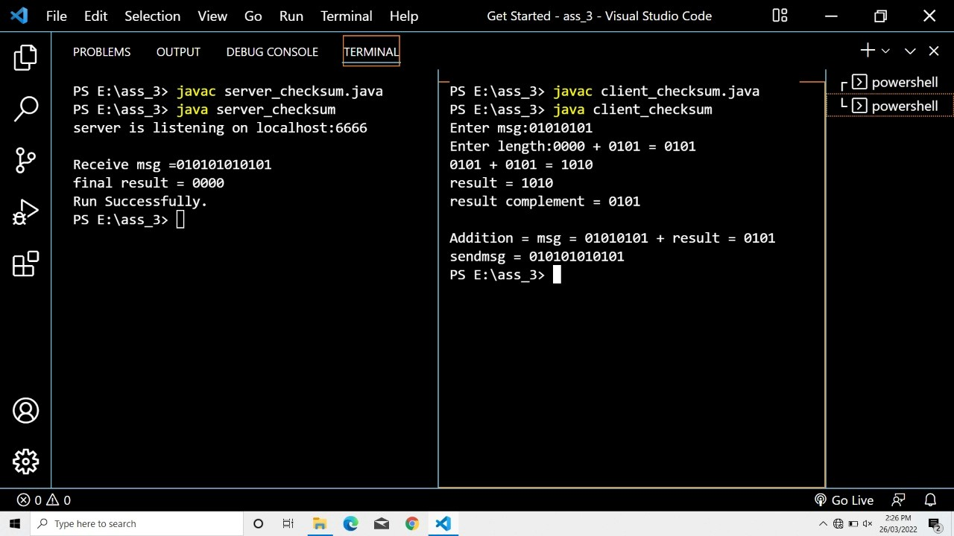

Program: 2

//Kumbhani Sanket-3111 import java.net.*; import java.io.*;

import java.util.Scanner;

class receiver_crc

{

public static void main(String args[]) throws Exception

{

try{

DatagramSocket ds1 = new DatagramSocket(6363); System.out.println("server listening on localhost:6363"); byte[] buf = new byte[500];

DatagramPacket dp1 = new DatagramPacket(buf,500); ds1.receive(dp1);

ds1.close();

String data = new String(dp1.getData(),0,dp1.getLength()); System.out.println("Received msg = "+ data);

String key = "11";

String rem = div(data,key); System.out.println("rem = "+rem); int cnt=0;

for(int i=0;i<rem.length();i++)

{

if(rem.charAt(i)=='0') cnt++;

}

if(cnt!=0)

System.out.println("No error -> Successful.");

// DatagramSocket ds2 = new DatagramSocket();

// Scanner s = new Scanner(System.in);

// System.out.println("server:");

// String msg1 = s.nextLine();

// InetAddress ip = InetAddress.getByName("localhost");

// DatagramPacket dp2 = new DatagramPacket(msg1.getBytes(),msg1.length(),ip,6565);

// ds2.send(dp2);

}catch(Exception e)

{System.out.println(e);}

}

public static String xor(String a, String b)

{

String result = "";

for(int i=1;i<a.length();i++)

{

if(a.charAt(i) == b.charAt(i)) result = result + "0";

else

result = result + "1";

}

return result;

}

public static String div(String data, String key)

{

int len = key.length(); for(int i=0;i<len-1;i++)

{

data = data + "0";

}

String zero = ""; for(int i=0;i<len;i++)

{

zero = zero + "0";

}

String temp = data.substring(0,len); while(len<data.length())

{

if(temp.charAt(0)=='1')

temp = xor(temp,key) + data.charAt(len); else

temp = xor(temp,zero) + data.charAt(len); len++;

}

if(temp.charAt(0)=='1') temp = xor(temp,key);

else

temp = xor(temp,zero);

return temp;

}

}

//Kumbhani Sanket-3111 import java.net.*; import java.io.*;

import java.util.Scanner;

class sender_crc

{

public static void main(String args[]) throws Exception

{

try{

DatagramSocket ds1 = new DatagramSocket(); Scanner sc = new Scanner(System.in); System.out.print("Enter Data: ");

String data = sc.nextLine(); String key = "11";

String rem = div(data,key); System.out.println("rem = "+rem); String sendmsg = data + rem;

System.out.println("send_msg = "+sendmsg); InetAddress ip = InetAddress.getByName("localhost");

DatagramPacket dp1 = new DatagramPacket(sendmsg.getBytes(),sendmsg.length(),ip,6363);

ds1.send(dp1);

}catch(Exception e)

{System.out.println(e);}

}

public static String xor(String a, String b)

{

String result = "";

for(int i=1;i<a.length();i++)

{

if(a.charAt(i) == b.charAt(i)) result = result + "0";

else

result = result + "1";

}

return result;

}

public static String div(String data, String key)

{

int len = key.length(); for(int i=0;i<len-1;i++)

{

data = data + "0";

}

String zero = ""; for(int i=0;i<len;i++)

{

zero = zero + "0";

}

String temp = data.substring(0,len); while(len<data.length())

{

if(temp.charAt(0)=='1')

temp = xor(temp,key) + data.charAt(len); else

temp = xor(temp,zero) + data.charAt(len); len++;

}

if(temp.charAt(0)=='1') temp = xor(temp,key);

else

temp = xor(temp,zero);

return temp;

}

}

# Output:

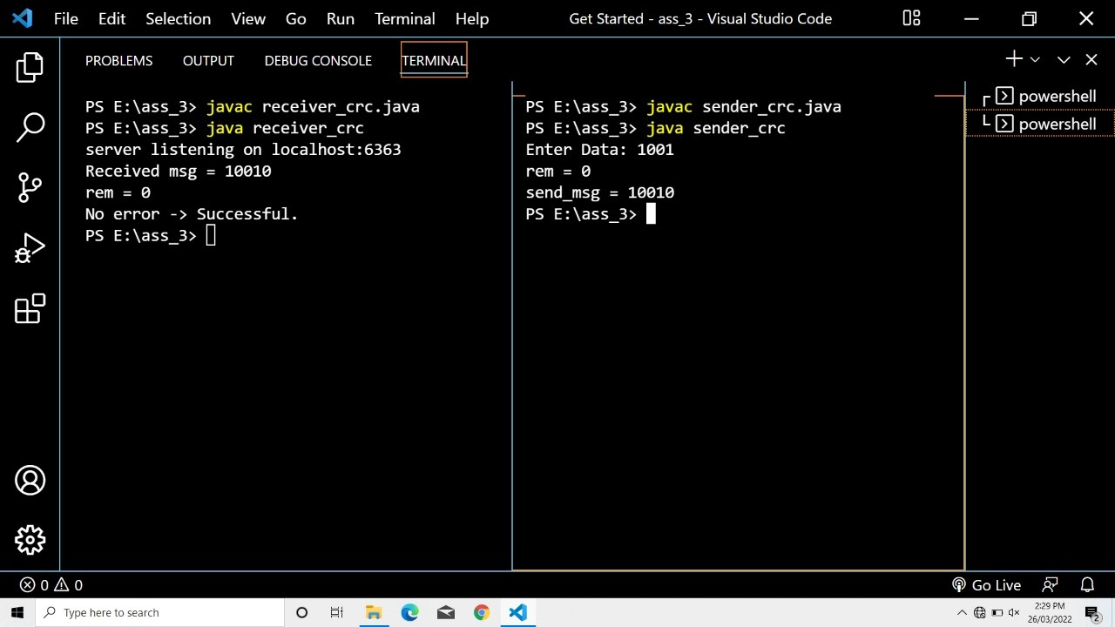

Program: 3

//Kumbhani Sanket-3111 import java.net.*; import java.io.*;

import java.util.Scanner; import java.lang.Math; import java.util.Arrays;

class receiver_hamming

{

public static void main(String args[]) throws Exception

{

try{

DatagramSocket ds1 = new DatagramSocket(6363); System.out.println("server listening on localhost:6363"); byte[] buf = new byte[500];

DatagramPacket dp1 = new DatagramPacket(buf,500); ds1.receive(dp1);

ds1.close();

String data = new String(dp1.getData(),0,dp1.getLength()); System.out.println("Received msg = "+ data);

// int a = Integer.parseInt(data);

// System.out.println(a); int totalbits = data.length(); int rbits = 3;

int databits = totalbits - rbits;

// System.out.println(totalbits); int rhcode[] = new int[totalbits+1];

//storing data into array for(int i=0;i<totalbits;i++)

{

rhcode[i] = data.charAt(i) - '0';

}

System.out.println("***** Received Code : *****"); for(int i=0;i<totalbits;i++)

{

System.out.print("rhcode["+i+"] : "+rhcode[i]+"\t");

}

System.out.println();

//create array to store errorbits int errorindex[] = new int[rbits];

for(int i=1,x=0,e=0; i<=totalbits; i++)

{

if(Math.pow(2,x)==i)

{

int counter = 0;

for(int sindex=i; sindex<=totalbits; sindex=sindex+i+i)

{

for(int index=sindex,cinc=1; index<=totalbits && cinc<=i; index++,cinc++)

{

"+hcode[index]);

//System.out.println("p["+index+"] :

if(rhcode[index] == 1)

{

counter++;

}

}

}

if(counter % 2 != 0)

{

errorindex[e]=i; e++;

}

x++;

}

}

//check if any error is there or not int sum=0;

System.out.print("\n errorIndex array values:"); for(int i=0;i<rbits;i++)

{

System.out.print(" "+ errorindex[i]);

sum = sum + errorindex[i];

}

//if sum < 0 then no error else error if(sum>0)

{

System.out.println("\n Error at index: "+ sum);

//correct error, flip the bit at error index (0 to 1) & (1 to 0) if(rhcode[sum]==0)

rhcode[sum]=1; else

rhcode[sum]=0;

}

else

{

System.out.println("\nNo error in hamming code.");

}

System.out.print("\n final received hamming code: "); for(int i=totalbits; i>=1; i--)

{

System.out.print(rhcode[i]);

}

System.out.println();

//extarct data from hamming code int rdata[] = new int[databits+1]; for(int i=1,x=1,d=0; i<=totalbits; i++)

{

if(Math.pow(2,x)==i)

{

x++;

}

else

{

rdata[d] = rhcode[i]; d++;

}

}

System.out.print("\n received Data: "); for(int i = databits; i>=1; i--)

{

System.out.print(rdata[i]);

}

System.out.println();

}catch(Exception e)

{System.out.println(e);}

}

}

//Kumbhani Sanket-3111 import java.net.*; import java.io.*;

import java.util.Scanner; import java.lang.Math;

class sender_hamming

{

public static void main(String args[]) throws Exception

{

try{

DatagramSocket ds1 = new DatagramSocket();

Scanner sc = new Scanner(System.in); System.out.print("Enter Length of data:"); int databits = sc.nextInt();

int rbits = 0; System.out.println("\nCalculating rbits:"); while(Math.pow(2,rbits) < databits+rbits+1)

{

1");

System.out.println("2^" + rbits + " < " +databits+" + "+rbits+" +

rbits++;

}

int totalbits = databits + rbits; System.out.println("\nData bits: "+databits); System.out.println("Redundent Bits: "+rbits); System.out.println("Total Bits: "+totalbits);

//create array and store the data int data[] = new int[databits+1];

//data stored in reverse order System.out.println("\nEnter data into array:"); for(int i=databits; i>=1; i--)

{

data[i] = sc.nextInt();

}

System.out.println();

//printing array

System.out.println("\n *****data array:*****"); for(int i=1;i<=databits; i++)

{

System.out.print("\tdata["+i+"] = "+data[i]);

}

System.out.println();

//create array & store hamming code int hcode[] = new int[totalbits+1];

//set values in hamming code

for(int i=1, x=0, k=1; i<=totalbits; i++)

{

if(Math.pow(2, x) == i)

{

hcode[i] = 0; x++;

}

else

{

hcode[i]=data[k]; k++;

}

}

//printing hcode array

System.out.println("\n *****hcode array:*****"); for(int i=1;i<=totalbits;i++)

{

System.out.print("\thcode["+i+"] = "+hcode[i]);

}

System.out.println();

//calculating value of rbits for(int i=1,x=0; i<=totalbits;i++)

{

if(Math.pow(2,x)==i)

{

int counter = 0; System.out.println("\nrbits index : "+i);

for(int sindex=i; sindex<=totalbits; sindex=sindex+i+i)

{

for(int index=sindex,cinc=1; index<=totalbits && cinc<=i; index++,cinc++)

{

System.out.print("\tp["+index+"] : "+hcode[index]); if(hcode[index] == 1)

{

counter++;

}

}

}

if(counter % 2 != 0)

{

hcode[i]=1;

}

else

{

hcode[i]=0;

}

x++;

}

}

//print final hamming code System.out.print("\n hamming code:\t"); String store = "";

for(int i=totalbits; i>=1; i--)

{

System.out.print(hcode[i]);

store += Integer.toString(hcode[i]);

}

System.out.println();

InetAddress ip = InetAddress.getByName("localhost"); DatagramPacket dp1 = new

DatagramPacket(store.getBytes(),store.length(),ip,6363); ds1.send(dp1);

}catch(Exception e)

{System.out.println(e);}

}

}

# Output:

